Invoice & Payment Documentation – Completion Guide



Document ID | DEV-FIN-SOP-001-v1.0
Product | Finance
Environment
Confidentiality Level | Internal

CONTENTS
1 DOCUMENT INFORMATION 3
1.1 Validation 3
1.2 Document Distribution 3
1.3 Version Control 3
2 PURPOSE & CONTEXT 4
2.1 About this document 4
2.2 Required Documents 4
2.3 Conventions Used 4
3 DOCUMENT COMPLETION GUIDELINES 5
3.1 Certificate of Foreign Status of Beneficial Owner (W-8BEN) 5
3.1.1 Who must complete it 5
3.1.2 How to complete it 5
3.2 Independent Contractor Agreement 6
3.2.1 Who must complete it 7
3.2.2 How to complete it 7
3.3 Copy of National ID 7
3.3.1 Who must complete it 8
3.3.2 How to complete it 8
4 APPROVAL SIGNATURES 9

DOCUMENT INFORMATION

Validation
Name |  | Role | Date (dd/mm/aa)
Issued by | Oscar Rondon | Technical Writer | 09/01/2026
Verified by | Vishal Bavadiya | Developer
Approved by

Document Distribution
Normal | Role
Oscar Rondon | Technical Writer
Anthony Bures | Digital Development Manager
Vishal Bavadiya | Developer

Version Control
Version | Date | Author | Description of changes
1.0 | 09/01/2026 | Oscar Rondon | First version of the document

PURPOSE & CONTEXT

About this document
This guide explains how independent contractors must correctly complete and submit the documents required to process payments and invoices.

Required Documents
Document | Mandatory | Purpose
Certificate of Foreign Status of Beneficial Owner for United States Tax Withholding and Reporting | Yes | Tax compliance
Independent Contractor Agreement | Yes | Legal agreement
Copy of National ID | Yes | Identity verification

Conventions Used
The following structures are used as recommendations.
Tip: A recommendation or useful advice

Warning: A warning or important notice

Note: A notice.

DOCUMENT COMPLETION GUIDELINES
Every contractor must fill out and submit the following documents:

Certificate of Foreign Status of Beneficial Owner (W-8BEN)
This form certifies that the contractor is not a U.S. person and establishes their foreign tax status for U.S. tax withholding and reporting purposes.

Who must complete it
- All non-U.S. individual contractors
Warning: Do not complete this form if you are a U.S. citizen or U.S. resident for tax purposes

How to complete it
Part 1. Identification of Beneficial Owner
- Full legal name
- Country of Citizenship
- Permanent residence address
- Mailing address (if different from above)
- U.S. taxpayer identification number (usually left blank)
- Foreign tax identification number (If not legally required, check the corresponding instructions)
- Reference Number (usually left blank)
- Date of Birth
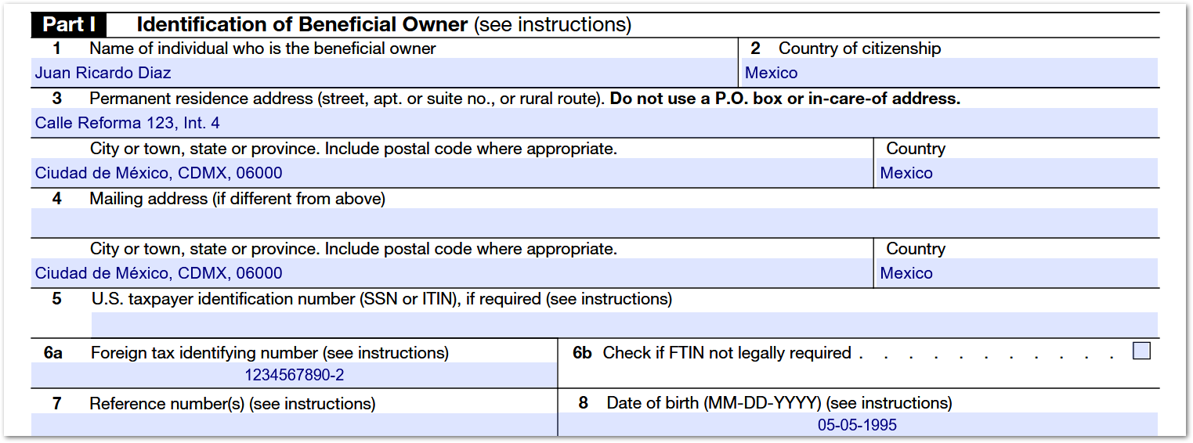

Part 2. Claim of Tax Treaty Benefits
- Complete only if your country has a tax treaty with the United States and you are claiming treaty benefits
- If unsure, leave this section blank (no treaty claim)
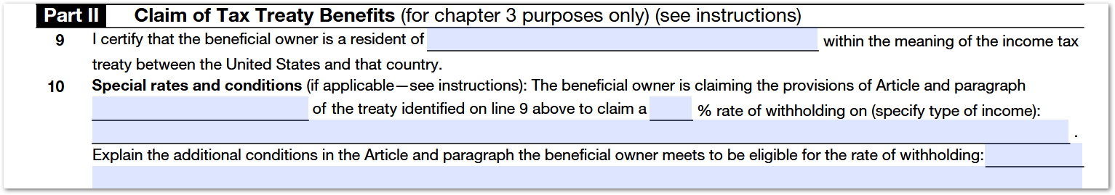

Part 3. Certification
- Sign and date the form
- Check the box to certify that you have the capacity to sign as the person identified
- Printed name must match the name in Part 1
Warning: Unsigned or Undated forms could be considered invalid.

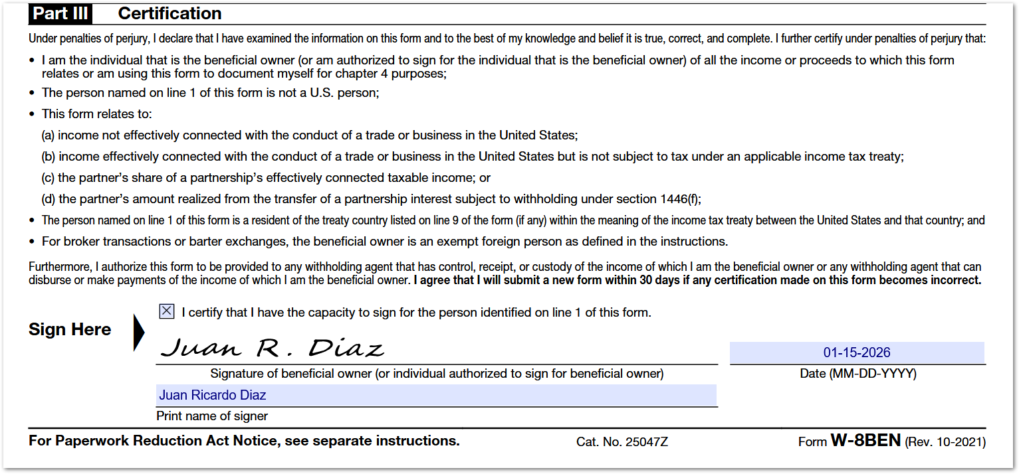

Independent Contractor Agreement
This agreement defines the legal relationship, scope of services, payment terms, confidentiality, and intellectual property ownership between the contractor and ZTERS.

Who must complete it
- All independent contractors or consultants.

How to complete it
Part 1. Agreement Header
Contractors must complete (page 1):
- Date of execution
- Full legal name
- Government ID number
Warning: The information provided here must match:
- National ID
- W-8BEN name
- Invoice details

Part 2. Signature Page
Contractors must complete (page 8):
- Name of contractor/consultant
- Signature (could be digitally signed)
- Date
- Name to print (consultant)
- Title or Role
- Address
- City, State and Zip
- Country
- Email address (personal or zters email)

Copy of National ID
A clear and valid copy of the contractor’s government-issued national identification document is required for identity verification purposes. The name on the ID must exactly match the name provided in the W-8BEN form and the Independent Contractor Agreement.


Who must complete it
- All independent contractors or consultants.

How to complete it
Add a PDF or Image copy of the contractor’s ID, the document must be:
- Legible
- Valid (unexpired)
- Complete
Warning: Blurry, cropped, or expired IDs may result in rejection and delay of payment processing.

Tip: Once all documents are completed, submit them via email to Anthony Bures.

APPROVAL SIGNATURES
Digital signature blocks below are formatted for DocuSign / Adobe Sign.
Role | Name | Digital Signature Block | Date (dd/mm/aa)
Technical Writer | Oscar Rondon |  | 09/01/2026
Digital Development Manager | Anthony Bures

--- END OF THE DOCUMENT ---

